Department of Electrical Engineering

Faculty Member: | Ma’am Neelma Naz | Date: | December 1, 2025
Semester: | 7th | Group: | 02

CS471 Machine Learning
Lab 11: Neural Networks

 |  | PLO4 | PLO5 | PLO5 | PLO8 | PLO9
 |  | CLO4 | CLO5 | CLO5 | CLO6 | CLO7
Student Name | Reg. No | Viva / Quiz / Demo | Analysis of Data in Report | Modern Tool Usage | Ethics | Individual and Teamwork
 |  | 5 Marks | 5 Marks | 5 Marks | 5 Marks | 5 Marks
Hanzla Sajjad | 403214
Irfa Farooq | 412564

Introduction
This laboratory exercise will focus on the introduction of Artificial Neural Networks which form a very wide and popular domain of machine learning. Due to the advancements in computing technology, neural networks have seen a major rise in machine learning implementations. They are used in many application areas such as in image classification, object detection, sequence models and natural language processing.

Objectives
The following are the main objectives of this lab:
- Implement Sigmoid and ReLU activation functions
- Initialize vectors/matrices for neural network implementation
- Use vectorization for neural network implementation
- Forward propagate to determine the loss
- Backward propagate to determine the weight derivatives
- Update weight parameters to fit the model

Lab Conduct
- Respect faculty and peers through speech and actions
- The lab faculty will be available to assist the students. In case some aspect of the lab experiment is not understood, the students are advised to seek help from the faculty.
- In the tasks, there are commented lines such as #YOUR CODE STARTS HERE# where you have to provide the code. You must put the code/screenshot/plot between the #START and #END parts of these commented lines. Do NOT remove the commented lines.
- Use the tab key to provide the indentation in python.
- When you provide the code in the report, keep the font size at 12

Theory
A Neural Network is an arrangement of numerous “neuron” units through which a dataset is propagated to determine the error of the model. The neuron units are stacked into a sequence of layers each of which learns a particular feature of the model. Associated between the layers are weighted parameters which are to be trained. The training examples are forward propagated through the network to determine the cost. The cost is then back propagated through the network to determine the change in the cost w.r.t. the change in the parameters. The result is then used to update the weights. At the end of the training, the weights will possess values which will cause the network to make a prediction with minimal errors.
A brief summary of the relevant keywords and functions in python is provided below:
print() output text on console
input() get input from user on console
range() create a sequence of numbers
len() gives the number of characters in a string
if contains code that executes depending on a logical condition
else connects with if and elif, executes when conditions are not met
elif equivalent to else if
while loops code as long as a condition is true
for loops code through a sequence of items in an iterable object
break exit loop immediately
continue jump to the next iteration of the loop
def used to define a function

pd.read_csv import csv file as a dataframe
df.to_csv export dataframe as a csv file

In this lab, you will write a python program that implements a shallow neural network from scratch. The neural network must contain an input layer (3 features), two hidden layers and one output layer. You are ONLY allowed to use NumPy, Pandas and MatplotLib modules.
In the given sections, you will program a vectorized implementation of the neural network, i.e. the features, labels and weights are contained inside vectors or matrices and the training will make extensive use of matrix implementations. Such vectorized methods have the advantage of being many times faster than using traditional loop-based implementation. Speed is an important metric in training as neural networks can be of extremely large sizes. As a result, NumPy computations form a central aspect of machine learning.
The pseudocode for the overall program is given as follows:
function definitions...
matrix initializations...
for epoch in epochs:
forward propagate through training examples
store training cost
back propagate using training cost
update the weights
forward propagate through test examples
store test cost
plot the training and test costs
save the weights on disk

Lab Task 1 – Activation Functions _________________________________________
After an input is propagated through the network weights, the resulting output is “activated” by applying a nonlinear function. Some of these activation functions are given as follows:
Sigmoid(z) = 1 / (1 + e^{-z})
ReLU(z) = max(0,z)
dReLU(z) = $\left\{\begin{aligned}0, z<0 \\ 1, z>0\end{aligned}\right.$
Write the code for each of the given activation functions. Call each function with any value for z and take screenshots of your work showing your printed output. Provide the code and all relevant screenshots.
Code
# Task 1: Activation Functions
# Implementing multiple activation functions
def sigmoid(x):
return 1 / (1 + np.exp(-x))

def ReLU(x):
return np.maximum(0, x)

def dReLU(x):
return np.where(x > 0, 1, 0)

# Testing each funtion's output for multiple values of z
z = [0, -5, 1.45, 120, 457]

for value in z:
print()
print(f"Value: {value}")
print(f"Sigmoid: {sigmoid(value)}")
print(f"ReLU: {ReLU(value)}")
print(f"dReLU: {dReLU(value)}")
print()

Output Console
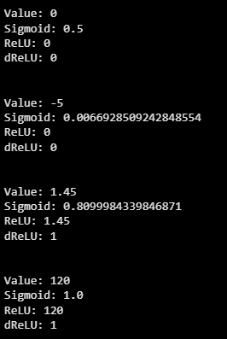

Download a dataset containing 3 feature columns and 1 label column with binary values. You will design and train a 3-layer neural network on your dataset to predict the y values.

Lab Task 2 – Matrix Initializations __________________________________________
Divide your dataset into training and test portions and import them into your python program. Write code to initialize the different matrices you need for your neural network implementation:
- Initialize all dataset examples as array X_{train} (n × m_{train}), X_{test} (n × m_{test})
- Initialize all corresponding labels as array Y_{train} (1 × m_{train}), Y_{test} (1 × m_{test})
- Initialize remaining layers Z₁, A₁, Z₂, A₂, Z₃, A₃ as zero arrays with appropriate sizes
- Initialize derivative layers dZ₁, dZ₂, dZ₃, dZ_{1cache}, dZ_{2cache}, dZ_{3cache} as zero arrays with appropriate sizes
- Initialize weight matrices W₁, B₁, W₂, B₂, W₃, B₃ with random numbers
- Initialize weight gradient matrices dW₁, dB₁, dW₂, dB₂, dW₃, dB₃ as zero arrays
Code
# Task 2: Matrix Initializations
from sklearn.model_selection import train_test_split

# Splitting the dataset
X_train, X_test, Y_train, Y_test = train_test_split(X, Y, test_size=0.2, random_state=42)

# Rearranging X and Y matrix dimensions
X_train = X_train.T
Y_train = Y_train.reshape(1, Y_train.shape[0])
X_test = X_test.T
Y_test = Y_test.reshape(1, Y_test.shape[0])

# Extracting index values of train and test dataset
n = 3 # Number of features of input layer

m_train = np.array(X_train.shape[1])
m_test = np.array(X_test.shape[1])

# Hidden Layer 1 variables
n_hl1 = 2 # Neurons in 1st layer
W1 = np.random.randn(n_hl1, n) # Weight Matrix
B1 = np.random.randn(n_hl1, 1) # Broadcasting
dW1 = np.zeros((n_hl1, n)) # Derivative Layers
dB1 = np.zeros((n_hl1, 1))

# Hidden layer 2 variables
n_hl2 = 3 # Neurons in 2nd layer
W2 = np.random.randn(n_hl2, n_hl1) # Weight Matrix
B2 = np.random.randn(n_hl2, 1) # Broadcasting
dW2 = np.zeros((n_hl2, n_hl1)) # Derivative Layers
dB2 = np.zeros((n_hl2, 1))

# Output layer variables
W3 = np.random.randn(1, n_hl2) # Weight Matrix
B3 = np.random.randn(1, 1) # Broadcasting
dW3 = np.zeros((1, n_hl2)) # Derivative Layers
dB3 = np.zeros((1, 1))

# Remaining Derivative layers
dZ1 = np.zeros((n_hl1, m_train))
dZ1_cache = np.zeros((n_hl1, m_train))

dZ2 = np.zeros((n_hl2, m_train))
dZ2_cache = np.zeros((n_hl2, m_train))

dZ3 = np.zeros((1, m_train))
dZ3_cache = np.zeros((1, m_train))

# Newron Outputs
Z1 = np.zeros((n_hl1, m_train))
Z2 = np.zeros((n_hl2, m_train))
Z3 = np.zeros((1, m_train))

# Activation Layers
A1 = np.zeros((n_hl1, m_train))
A2 = np.zeros((n_hl2, m_train))
A3 = np.zeros((1, m_train))

Lab Task 3 – Forward Propagation ________________________________________
Write the code for implementing forward propagation given as follows:
Z₁ = W₁X + B₁ A₁ = ReLU(Z₁)
Z₂ = W₂A₁ + B₂ A₂ = ReLU(Z₂)
Z₃ = W₃A₂ + B₃ A₃ = Sigmoid(Z₃)
Ensure that your forward propagation function works on both training and test datasets. Run your code on both the training and test datasets to give out their respective costs. Provide the code and all relevant screenshots of the final output.
Code
# Task 3: Forward Propogation

def Forward_Propogation(Xtrain, Xtest, Ytrain, Ytest, w1, b1, w2, b2, w3, b3):
# Computation on training dataset
Z1 = w1 @ Xtrain + b1
A1 = ReLU(Z1)
Z2 = w2 @ A1 + b2
A2 = ReLU(Z2)
Z3 = w3 @ A2 + b3
A3 = sigmoid(Z3)

# Computation on test dataset
Z1_test = w1 @ Xtest + b1
A1_test = ReLU(Z1_test)
Z2_test = w2 @ A1_test + b2
A2_test = ReLU(Z2_test)
Z3_test = w3 @ A2_test + b3
A3_test = sigmoid(Z3_test)

# Computing cost for training and test
cost_train = -1 / m_train * np.sum(Ytrain * np.log(A3) + (1 - Ytrain) * np.log(1 - A3))
cost_test = -1 / m_test * np.sum(Ytest * np.log(A3_test) + (1 - Ytest) * np.log(1 - A3_test))

return cost_train, cost_test, Z1, A1, Z2, A2, Z3, A3, Z1_test, A1_test, Z2_test, A2_test, Z3_test, A3_test

# calling function
cost_train, cost_test, Z1, A1, Z2, A2, Z3, A3, Z1_test, A1_test, Z2_test, A2_test, Z3_test, A3_test = Forward_Propogation(X_train, X_test, Y_train, Y_test, W1, B1, W2, B2, W3, B3)

# Printing the costs
print(f"Training Cost: {cost_train}")
print(f"Test Cost: {cost_test}")

Output Console
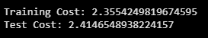

Lab Task 4 – Backward Propagation ________________________________________
Write the code for implementing backward propagation given as follows:
dZ_{3cache} = dZ₃
dZ₃ = A₃ - Y_{train}
dW₃ = $\frac{1}{m}{(dZ}_{3cache} . A_{2}^{T})$
dB₃ = sum dZ_{3cache} across training examples axis

dZ_{2cache} = dZ₂
dZ₂ =${(W}_{3} . {dZ}_{3})$ .* dReLU(Z₂)
dW₂ = $\frac{1}{m}{(dZ}_{2cache} . A_{1}^{T})$
dB₂ = sum dZ_{2cache} across training examples axis

dZ_{1cache} = dZ₁
dZ₁ =${(W}_{2} . {dZ}_{2})$ .* dReLU(Z₁)
dW₁ = $\frac{1}{m}{(dZ}_{1cache} . X^{T})$
dB₁ = sum dZ_{1cache} across training examples axis

When working on back propagation, it is helpful to note the sizes of the matrices involved in the equations. Once the weight gradients dW₁, dB₁, dW₂, dB₂, dW₃, dB₃ are found, the weights can be updated using gradient descent:
$$W_{L}=W_{L}-α\frac{∂J}{∂W_{L}}=W_{L}-α{ dW}_{L}$$
$$B_{L}=B_{L}-α\frac{∂J}{∂B_{L}}=B_{L}-α{ dB}_{L}$$
The subscript L indicates the layer number. Run your code by first using forward propagation on the training dataset to determine the cost. Then, back propagate to find the derivatives (of cost w.r.t. weight). Finally, use the derivatives to update the weights. Provide the code and all screenshots showing the initial weights, cost, derivatives and updated weights.

Code
def Backward_Propogation(Xtrain, Xtest, Ytrain, Ytest, w1, b1, w2, b2, w3, b3, alpha):

# Forward pass
cost_train, cost_test, Z1, A1, Z2, A2, Z3, A3, Z1_test, A1_test, Z2_test, A2_test, Z3_test, A3_test = Forward_Propogation(
Xtrain, Xtest,
Ytrain, Ytest,
w1, b1, w2, b2, w3, b3
)

# Computing Backward Propagation
dZ3 = A3 - Ytrain
dZ3_cache = dZ3
dW3 = (1/m_train) * (dZ3_cache @ A2.T)
dB3 = (1/m_train) * np.sum(dZ3_cache, axis=1, keepdims=True)

dZ2 = (w3.T @ dZ3) * dReLU(Z2)
dZ2_cache = dZ2
dW2 = (1/m_train) * (dZ2_cache @ A1.T)
dB2 = (1/m_train) * np.sum(dZ2_cache, axis=1, keepdims=True)

dZ1 = (w2.T @ dZ2) * dReLU(Z1)
dZ1_cache = dZ1
dW1 = (1/m_train) * (dZ1_cache @ Xtrain.T)
dB1 = (1/m_train) * np.sum(dZ1_cache, axis=1, keepdims=True)

# Updating weights
w1 -= alpha * dW1
b1 -= alpha * dB1
w2 -= alpha * dW2
b2 -= alpha * dB2
w3 -= alpha * dW3
b3 -= alpha * dB3

return w1, b1, w2, b2, w3, b3, dW1, dB1, dW2, dB2, dW3, dB3, dZ1, dZ2, dZ3, cost_train, cost_test

# Calling Backward Propagation
W1, B1, W2, B2, W3, B3, dW1, dB1, dW2, dB2, dW3, dB3, dZ1, dZ2, dZ3, train_cost, test_cost = Backward_Propogation(
X_train, X_test,
Y_train, Y_test,
W1, B1,
W2, B2,
W3, B3,
alpha = 0.01
)

# Printing results
print("\nDerivatives")
print("dZ1:", dZ1)
print("dW1:", dW1)
print("dB1:", dB1)

print("\ndZ2:", dZ2)
print("dW2:", dW2)
print("dB2:", dB2)

print("\ndZ3:", dZ3)
print("dW3:", dW3)
print("dB3:", dB3)

print("\nUpdated Weights")
print("W1:", W1)
print("B1:", B1)
print("W2:", W2)
print("B2:", B2)
print("W3:", W3)
print("B3:", B3)

Output Console
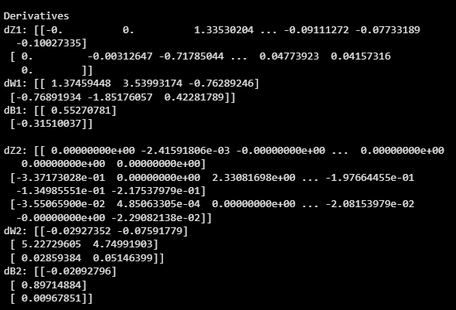

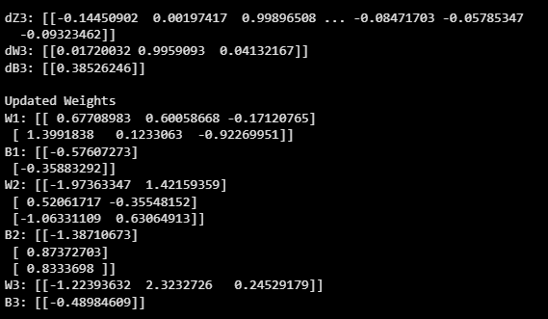

Lab Task 5 – Training and Testing ____________________________________
In this task, you will use the functions from the previous tasks to write a “main” function that performs the actual training and testing.
First, forward propagate through the training examples to determine the training cost. Then, back propagate to determine the weight gradients. Next, use the gradients to update the weights. Finally, forward propagate through the test examples to determine the test cost. This single iteration over the entire dataset (both training and test) marks completion of one epoch.

You will need to perform the training and testing over several epochs (the epoch number is another hyperparameter that must be chosen). Ensure that at the end of each epoch, the training and test losses are stored for plotting purposes. When the final epoch is performed, save the trained parameters (weights and bias) and make plot of the training and test losses (y-axis) over the epochs (x-axis). Ensure that both of the losses appear on the same graph.

Tune the alpha parameter to some other values to obtain more plots. You will need to obtain at least 9 plots. Ensure that the alpha value is mentioned on each plot. Provide the code (excluding function definitions), all relevant screenshots and plots.

You will also need to submit the best trained weights as part of the submission.

Code
# Task 5: Training and Testing

# Creating main function
def main(Xtrain, Xtest, Ytrain, Ytest, w1, b1, w2, b2, w3, b3, epochs, alpha):
train_cost_history = []
test_cost_history = []

for epoch in range(epochs):
# Calling Backward Propagation
w1, b1, w2, b2, w3, b3, dw1, db1, dw2, db2, dw3, db3, dz1, dz2, dz3, train_cost, test_cost= Backward_Propogation(
Xtrain, Xtest, Ytrain, Ytest,
w1, b1, w2, b2, w3, b3,
alpha
)
train_cost_history.append(train_cost)
test_cost_history.append(test_cost)

# Plotting training and test cost vs epochs
plt.plot(train_cost_history, label="Training Cost")
plt.plot(test_cost_history, label="Test Cost")
plt.xlabel("Epochs")
plt.ylabel("Cost")
plt.legend()
plt.show()

# Calling main
main(X_train, X_test, Y_train, Y_test, W1, B1, W2, B2, W3, B3, epochs = 5000, alpha = 0.01)

Output Console

